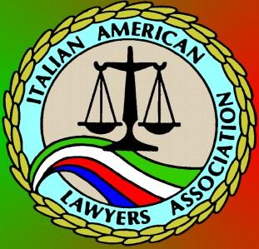

ITALIAN AMERICAN LAWYERS ASSOCIATION
Casa Italiana, 1051 N. Broadway, LA, CA 90012
Government Night CLE/Past Presidents Night: General Dinner Meeting featuring
L.A. County District Attorney Jackie Lacey &
L.A. City Attorney Michael Feuer
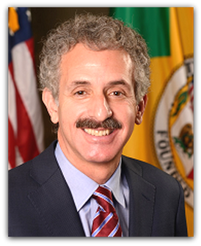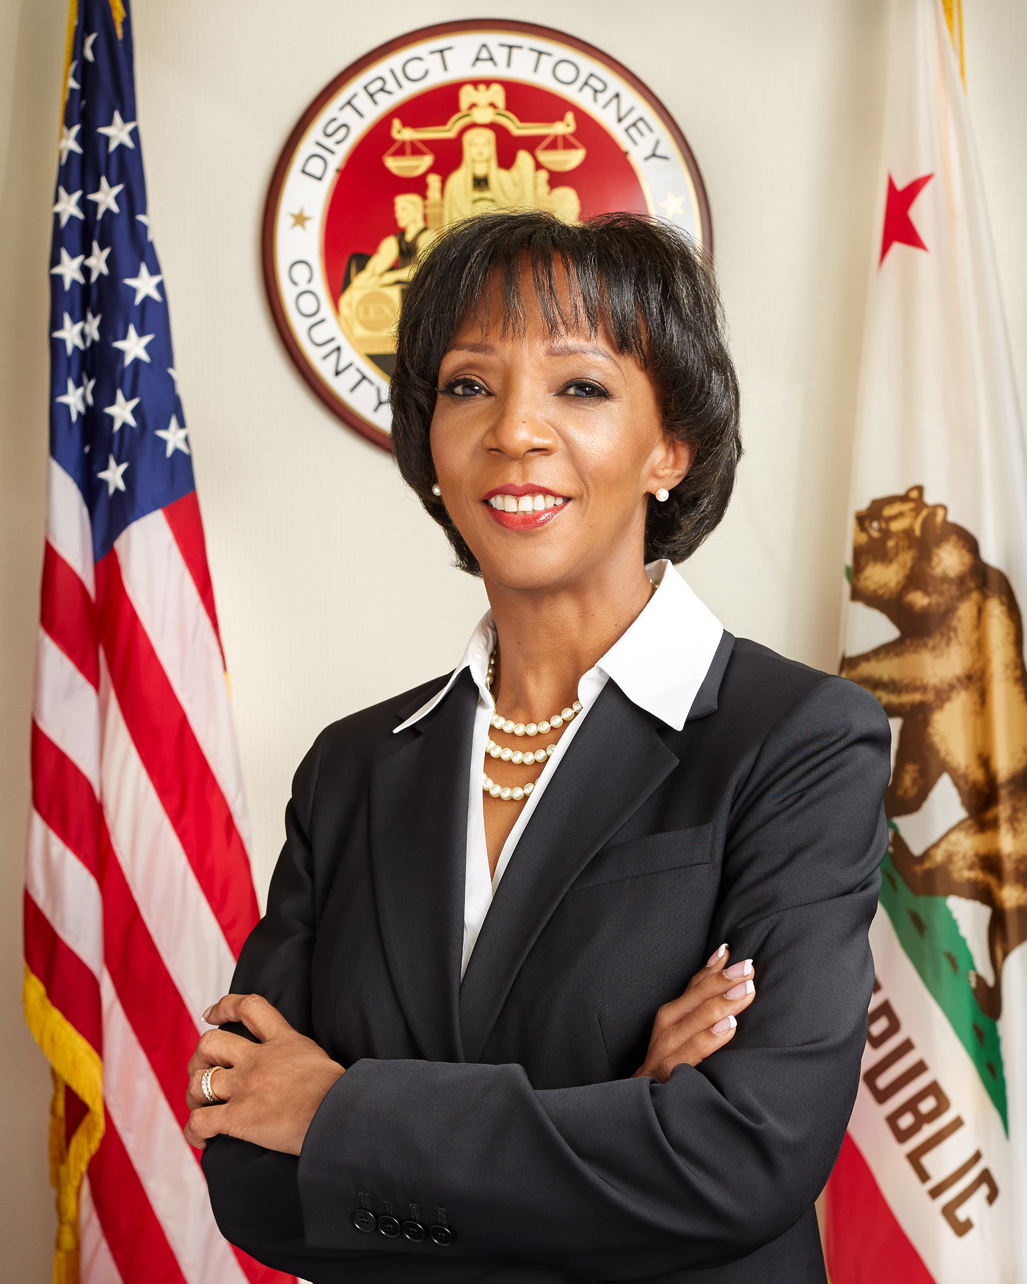
Special introductions by: L.A. D.A. Robert Philibosian (ret.) &
St. Assemblyman Michael Gatto (ret.)

and

NOVEMBER 15, 2017
6:00 pm: Cocktails and Music, Wine Tasting with Stolpman Winery
7:00 pm – 9:00 pm: Dinner and Program
Entrée Selection: Chicken, Sausage & Peppers, or Vegetarian Eggplant Parmesan
All dinners come with Antipasto, Mostaccioli, Spumoni, Wine and 1 CLE credit

RSVP by November 10th at our Event Page: http://iala38.wildapricot.org/page-1836071
Meal selections not guaranteed after the RSVP deadline.

Prices:
Non-Members: $55 with RSVP and payment received prior to the event
IALA Members; Retired Judges; WLALA; BWLALA; MCBA LACBA Government Section/: $50 with
Sitting Judges: Free! / Students: $25 / Tables of 8: $400
All payments at the door will be $10 more than the above-listed prices.
Payment:
Pay via PayPal at the link above where you can RSVP or Mail checks to
IALA, PO Box 712057, Los Angeles, CA 90071, but still RSVP online if possible.

Questions or feedback? E-mail us at iala07@yahoo.com or call 213-891-4845

