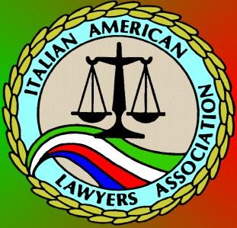

ITALIAN AMERICAN LAWYERS ASSOCIATION
Casa Italiana, 1051 N. Broadway, LA, CA 90012
East West Night (fka Marco Polo Night): General Dinner Meeting featuring
California State Treasurer John Chiang – Jointly Hosted by:
IALA, SCCLA, JABA, APABA, APAWLA, PABA, TABA, SABA & Armeni Bar
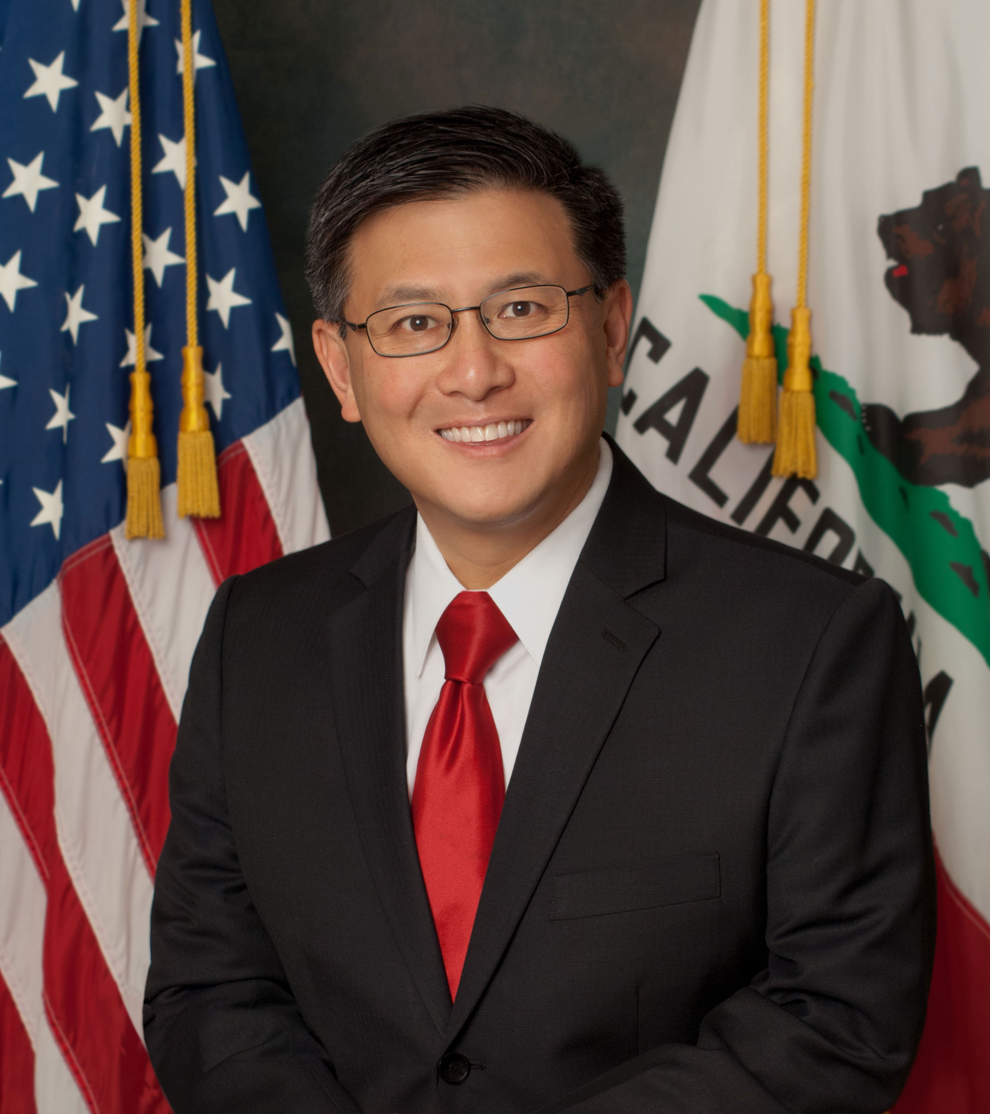

OCTOBER 4, 2017
6:00 pm: Cocktails and Music
7:00 pm – 9:00 pm: Dinner and Program

Entrée Selection: Chicken, Sausage & Peppers, or Vegetarian Eggplant Parmesan
All dinners come with Antipasto, Mostaccioli, Spumoni, and Wine

RSVP by September 30th at our Event Page: http://iala38.wildapricot.org/page-1836071
Meal selections not guaranteed after the RSVP deadline.

Prices:
Non-Members: $55 with RSVP and payment received prior to the event
IALA, SCCLA, JABA, APABA, APAWLA, TABA, MCBA, SABA, and ArmeniBar Members; Retired Judges; $50 with RSVP and payment received prior to the event
Sitting Judges: Free! / Students: $25 / Tables of 8: $400
All payments at the door for walk-ins will be $10 more than the above-listed prices.
Payment:
Pay via PayPal at the link above where you RSVP or Mail checks to
IALA, P.O. Box 712057, Los Angeles, CA 90071, but still RSVP online.

Questions or feedback? E-mail us at iala07@yahoo.com or call 213-891-4845

